**Q2. Revising the Select Query II**

Query the NAME field for all American cities in the CITY table with populations larger than 120000. The CountryCode for America is USA.

The CITY table is described as follows:

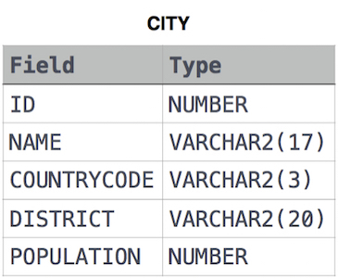

Ans.

SELECT NAME

FROM CITY

WHERE COUNTRYCODE = 'USA' AND POPULATION

> 120000